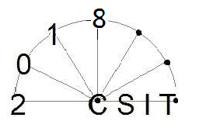 | The 20th International Workshop on Computer Science and Information Technologies  (20thCSIT’2018)  September 24-26, 2018, Bulgaria, Varna
Dear participant of the International Conference 20thCSIT'2018 please fill the following form:
NAME (as in passport)
SURNAME (as in passport)
UNIVERSITY
DEPARTMENT
APPOINTMENT
POSITION
ACADEMIC DEGREE
ADDRESS
TEL, MOBILE TEL
E-MAIL
FORM OF PARTICIPANCE (FULL/ONLY PUBLICATION)
FORM OF PARTICIPANCE (FULL/ONLY PUBLICATION) | Arrival date | Departure date
Accommodation(Single/Double)
REPORT TITLE

Return this form by email, mail or fax to:
20thCSIT 2018 Workshop Secretariat,
e-mail: csit.usatu@gmail.com

Fax: +7 347 2737717
Tel: +7 347 2737967

